The Superhyperpolyglot
By Ezgi Bas
I speak about a hundred languages. I know this seems implausible, but you probably do as well.
The first language I learned was Turkish, with my family. Even as a little kid who
couldn’t form complete sentences, I insisted on chatting with the adults around me. I would insist
on joining every conversation at dinner parties, or blabbing about whatever I wanted if I didn’t
understand any of the dialogues happening. This ability and enthusiasm were taken from me when I moved to the U.S. in 2016 at the age of 13. Every time I wanted to say something, I just
couldn’t find the words that needed to come out of my mouth. Even when greeting people, I
would accidentally say günaydın and not good morning.
So, I took comfort in the familiarity of math, not a subject I particularly loved or was
good at in Türkiye. Math became the clearest way I could communicate my ideas, because it was
the same in both places. Even after living and communicating primarily in English for almost a
decade, I count in Turkish, bir, iki, üç. I do arithmetic in Turkish, yedi çarpı sekiz elli altı.
Ultimately, the number I write on the page is the same. Mathematical concepts — numbers,
operations, formulas — have names in my other languages like Turkish and English, but carry
the same meaning regardless of their names. Just like Japanese and Mandarin share characters but pronounce them differently, math is a language with a set of characters that I pronounce multiple ways.
星 星
xīng hoshi
“star” “star”

⁂
On road trips with my grandparents, I would constantly pester them for a story or a joke.
Driving through the night in a packed car with both parents and my grandparents, I asked my grandmother to tell me a fıkra, a humorous short story. And then another. And another, and
another. I asked for more fıkras than any grandmother could memorize, and when she protested
“Fıkra’nın f’si bile kalmadı artık!”, “I don’t even have the f of fıkra anymore!” I responded, “O zaman bana bir ıkra anlat”, “Then tell me an ıkra.”
Many of the fıkras in Türkiye are so famous that everyone can reference them just by
their punchline. Since we all know the story, we know why the punchline is funny.
When I first learned derivatives in high school, they seemed empty, like a punchline without a story. Derivatives were strict rules, meant to be memorized and used, but never
questioned. There wasn’t room for play, which is what I loved so much about language. I was
simply told that a formula was true, without knowing why it was so.
The first rule I learned was the product rule, a formula for taking the derivative of two
functions that are multiplied together.
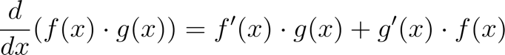
This equation is true like a punchline is funny, but why? I figured if I could write the
story of how it came to be, I would be more likely to believe it. So, I came up with my first proof. I sat alone with an empty whiteboard in a classroom at my high school, thinking about what I already knew that could help me start. I began with the definition of a derivative; introducing the first character in my story:
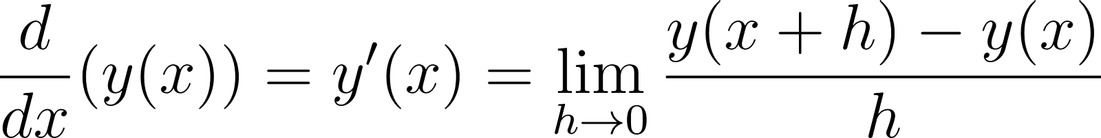
The rest came with a bit of experimentation: moving things around, adding and subtracting terms
until I got to the formula I was trying to prove.
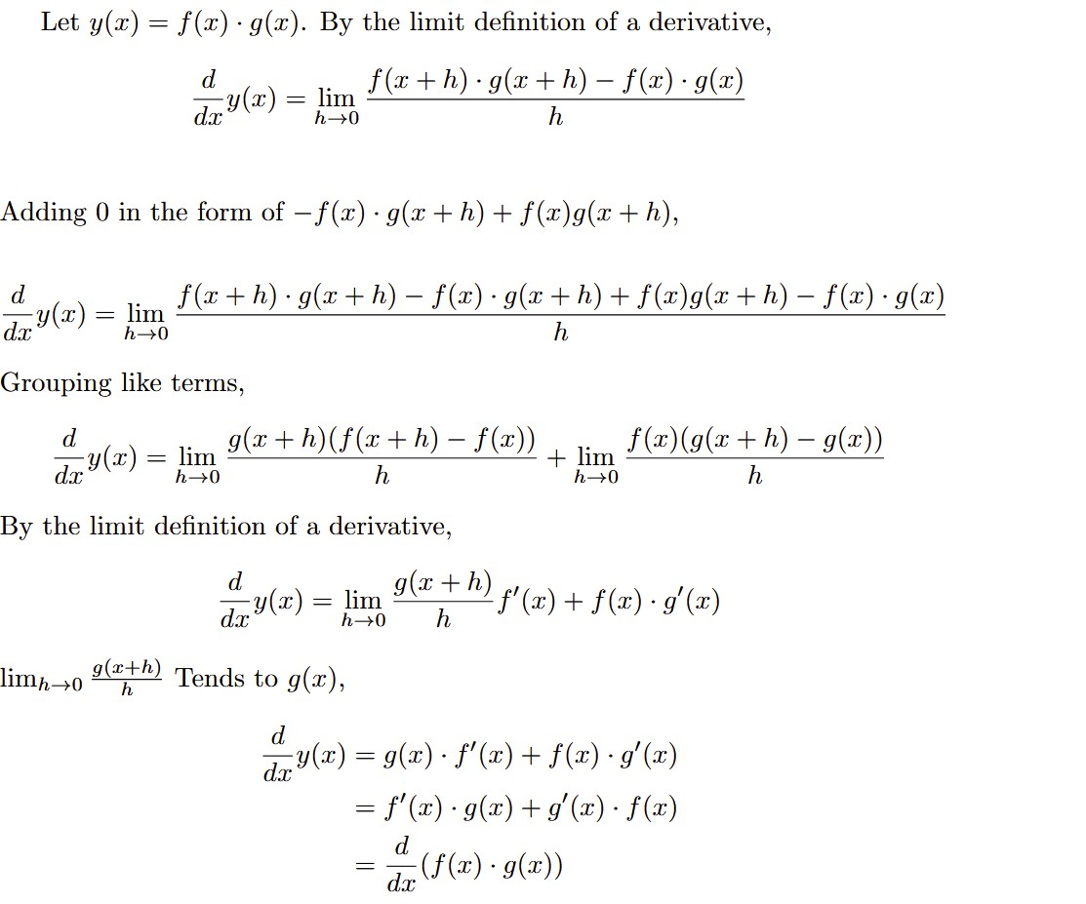
This was the story I came up with, with the final line as my punchline: the formula I was trying to prove. With this proof, I had replicated what Leibniz had done hundreds of years ago: discovered why and how the product rule works. After years of learning the language of math in
the form of formulas and rules, I had finally found the story that made me believe them.
Just like Turkish or English, math became a language not just for communication but also
play. At first, I wrote these proofs to make it easier on myself to believe and memorize the
formulas. Each one came with a new challenge. For some, I had to walk into the math office and
ask my teachers about concepts I had learned in previous classes. Some were longer, complicated; some were straightforward. As I completed each one, I started to enjoy the puzzle
that came with it. Just like fooling my grandmother to tell me another ıkra because she claimed
she had no f’s left, I had to come up with a new technique of play to reach a new truth.
⁂
I was always intimidated by computer science when I was younger, especially because I
had to use programming “languages.” I already knew how hard learning a second language was;
it had taken me years to learn English, and I was still trying to learn Spanish. How did people
know multiple of these programming “languages!?”
In fact, programming languages are similar to languages in the way that they have a
vocabulary, a grammar, and a widely-accepted way to use them. However, these vocabularies and grammars are significantly more limited than a human language, enough that a novice could pick up the basics within 2 weeks, which is what I did with JavaScript.
In my third year of high school, I decided to teach myself the Java course taught at school. When I was learning JavaScript, my instructors taught me “procedural” programming: a
piece of code does something, like add two numbers together, or find the smallest element in a
list. Java was from a different family of programming languages, it was “object-oriented”. This
was a difficult concept to wrap my mind around. A piece of code I wrote didn’t do something, it
was something. An object.
I practiced the concept by mapping Java principles onto my daily life. I was the [Name] object, and my parents were the Anne and Baba objects. The Anne object could ask [Name] to bring her water, and [Name] would return water. Baba could ask [Name]to fold the Sheets object, and the [Name] object would fold the Sheets and return void, not giving a response but still completing the task.
Understanding object-oriented programming gave me a new way of understanding the
world, a new way of modeling real life into code. In college, I learned functional programming
which was the complete opposite of object-oriented programming. Instead of representing the
real world with “things,” I had to represent them with functions, similar to one I might use in
calculus. I felt almost lost learning yet another family of programming languages, just as I had
with Java.
Every programming language, despite being a challenge, is also a new tool. With each
new way of thinking, I have a new lens with which I could learn about the world. It’s as if some
languages are microscopes that allow me to focus on the details, the building blocks of life.
These are “low-level” languages, the ones that make me explicitly deal with the bits and switches
on my computer to write programs. Other languages are telescopes, they allow me to observe
large-scale movements in the universe. I use these “high-level” languages to process large
amounts of data, without worrying about how the computer deals with it.
⁂
“Linguistic processes are pervasive in most fundamental domains of thought, unconsciously shaping us from the nuts and bolts of cognition and perception to our loftiest abstract notions and major life decisions.”
— Boroditsky: How Does Our Language Shape The Way We Think?
In every language I speak, I’m able to provide different information about the same story.
If I want to tell a story about my roommates going to the store, I can say “They went to the store.” Or, I could say “Ellas fueron a la tienda,” immediately giving you more information about
my roommates: they’re all girls, or else I would have used “ellos.” In Turkish I have two options:
“Markete gittiler” or “Markete gitmişler.” The former, “Markete gittiler,” tells you that I know
they went to the market, whereas in the latter I’m not sure if that is true, my statement tells you I
acquired my information from an external source.
Natural languages like Turkish, English, and Spanish are inherently ambiguous. In every word there is room for humor, sarcasm, and showing emotion. The laws of the universe cannot be expressed in such an ambiguous way. The language of math, despite being creative and playful, does not have this ambiguity. Perhaps I cannot tell you a story about my roommates going to the store in the language of math, but I can tell you the story of how they can go to the store. What kinds of natural laws are at play so that they can walk, stand? What economic factors make it so that the products of the store are priced the way they are? These are the stories I can tell you with math.
Programming languages allow me to turn these stories into an experience. They allow me
to communicate with my computer in such a way that the stories become immersive. They
combine the certainty of math with the emotionality of language. The way I communicate with
my computer is exact, rule-based. But what my computer can communicate to you as a result is a
story that you control—one that blends logic with human creativity.
⁂
“A new language is almost a new life, grammar and syntax recast you, you slip into another logic and another sensibility.”
— Lahiri: Teach Yourself Italian
If you asked a linguist, they would probably tell you I don’t actually “speak about a
hundred languages,” and they are right. However, I do speak hundreds of dialects of each
language I know, as do you. I speak a familect with my parents, my roommates, and my friends.
Some of them are derivatives of English, some Turkish, and some Spanish. These familects are only understood within my family or group of friends. We have our own vocabulary, and we may even modify our grammar in specific ways. These elements of our language are shaped by our lives that we share, and the act of using the language is in itself an intimate act.
Each language serves a different purpose. Some for connecting with my family, some for debating with my friends, and some for presenting in class. Even in math, I use a different
language for a formal proof than when I’m explaining a problem to a friend. In computer science, I use different types of programming languages to solve different problems.
We all underestimate the number of languages that are in our lives. Language is a skill we have all honed slowly since the day we started babbling as babies. It's not just something we use;
it's something we create—and we do so because we are human. As humans we need to connect,
learn, analyze, teach, play. And we do this through languages that we shape for our unique
purposes. To create a language is our natural skill as humans, and it is what makes us human.

Works Cited
Boroditsky, Lera. “HOW DOES OUR LANGUAGE SHAPE THE WAY WE THINK?”
Edge.org, 2019, www.edge.org/conversation/lera_boroditsky-how-does-our-language-shape-the-way-we-think
Finegan, Edward. Language : Its Structure and Use. Fort Worth, Harcourt Brace College
Publishers, 1999.
Gordon, Cynthia. Making Meanings, Creating Family. Oxford University Press, 12 Aug. 2009.
Lahiri, Jhumpa. “Teach Yourself Italian.” The New Yorker, 29 Nov. 2015,
www.newyorker.com/magazine/2015/12/07/teach-yourself-italian.

See: Gordon: Making Meanings, Creating Family.

